Below figure shows how to find d:

One way is using cos function as base/hypotenuse, therefore

d = ||a|| cosθ.

Second way which is derived one(given in below fig)

d = a.b / ||b||

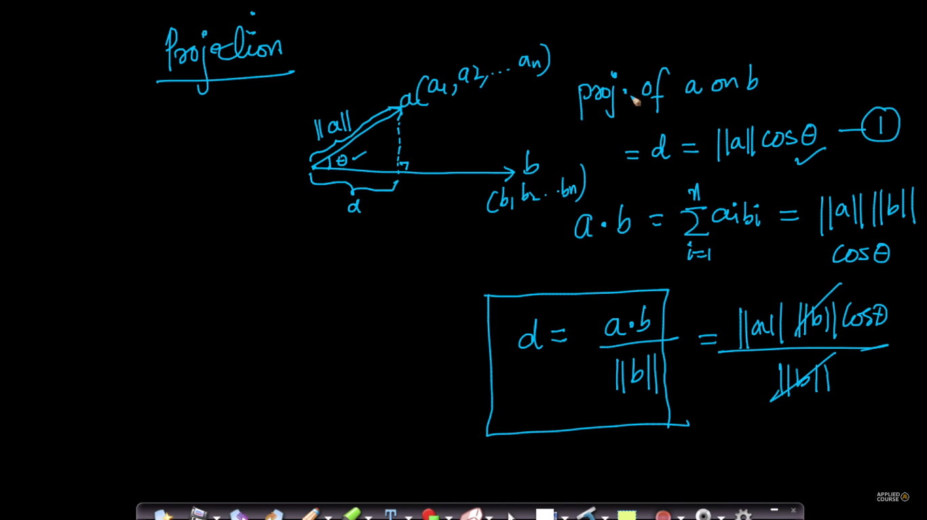

**Unit Vector:** unit vector tells about the direction of the vector. If the modulus of vector is 1 it is unit vector.

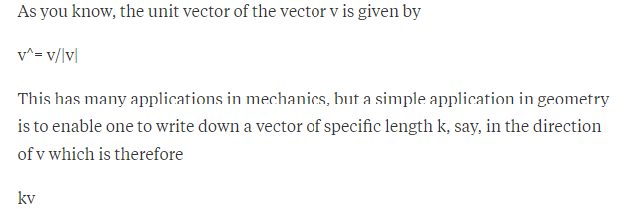

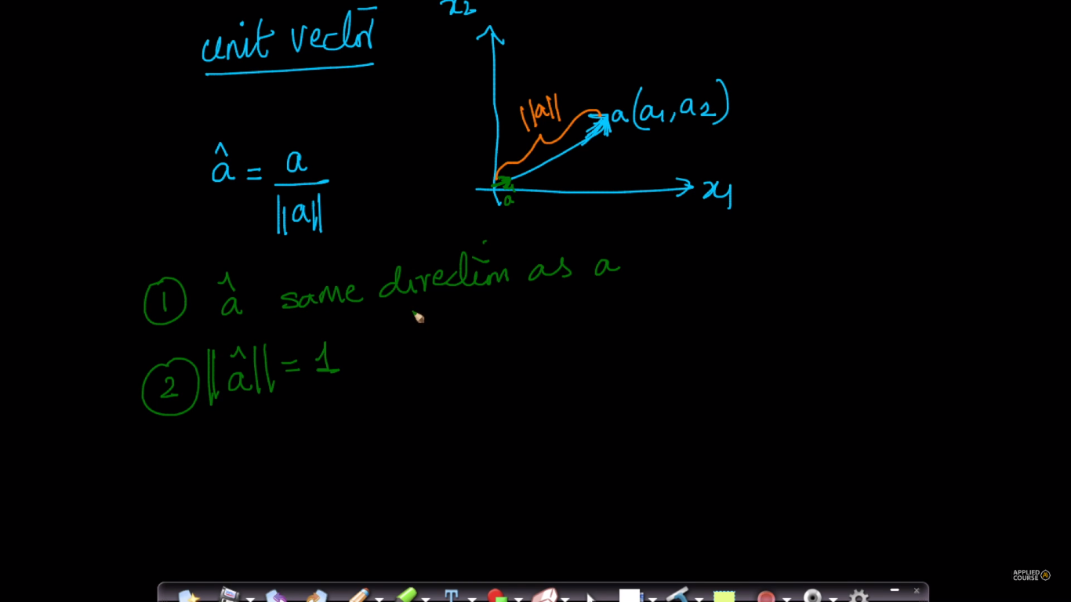

**what is use of finding the angle between the two vectors and in ML point of view how we will interpreter theta?**

if we find the angle between two vectors ( angular distance ), we can know how similar are those two vectors.   
theta = 0 --> two vectors are in same direction  
theta = 90 --> two vectors are orthogonal to each other  
theta = 180 --> two vectors are in opposite direction.   
real-time use case:   
if you have a credit card fraud data point let us say 10 dimension point, then you can find similar transactions by finding the angle between a new data point and fraud data point so that we will get to know how similar are those points in 10-dimensional space.

a data point nothing but a vector. so we can find angle between out data and new data i.e two vectors using theta = cos^-1( a.b / ||a||.|b||). here a is fraud data vector we have and b is new data vectors we got.